ACCOMPLISHMENT REPORT
IT 307 & 307L – Event-Driven Programming
Month: August & September – Year: 2025
School Year: 2025 – 2026 1st Semester

DATE | ACCOMPLISHMENT | REMARKS  (Progress and deviations from the plan) *
August 18 – 22, 2025 | Orientation  - SLSU Vision, Mission, Goals, Objectives and Quality Policy  - Program Outcomes  - Course Outcomes  - Course Outline  - Course Requirements  - Gender Awareness and Development (GAD)  - Course Grading System  - Student/s with Special Needs  - Disaster and Risk Preparedness  Lecture Accomplishments:  - Explained the principles, architecture, and workflow of event-driven programming to build a strong foundation.  - Differentiated procedural, object-oriented, and event-driven approaches by comparing their program flow and design focus.  Laboratory Accomplishments:  - Defined the key characteristics of Event-Driven Programming through code examples and discussion.  - Conducted a simple hands-on task where students implemented a basic JavaScript client-side event program. | Accomplished,  Accomplished,  Accomplished
August 25 – 29, 2025 | Lecture Accomplishments:  - Analyzed event-handling processes, including bubbling, tunneling, synchronous, and asynchronous patterns, to understand how events move in systems.  - Applied secure coding and error handling practices in event-driven applications, stressing the importance of reliability and ethics.  Laboratory Accomplishments:  - Differentiated Event-Driven Programming from Procedural and Object-Oriented Programming through code samples and observation.  - Conducted a hands-on coding task where students created a simple PHP server-side form submission event program. | Accomplished,  Accomplished
September 1 – 12, 2025 | Lecture Accomplishments:  - Explained advanced event-handling processes, showing how bubbling and tunneling affect program execution.  - Compared synchronous and asynchronous event patterns and evaluated their strengths in real-world applications.  - Applied ethical practices by teaching secure coding and error-handling methods in event-driven systems.  - Demonstrated adaptability by introducing new frameworks that support modern event-driven applications.  - Designed sample JavaScript-based GUI programs to show effective event-handling mechanisms in web interfaces.  Laboratory Accomplishments:  - Implemented a JavaScript client-side program using multiple event handlers to practice responsiveness.  - Conducted coding tasks where students built a PHP-based server-side programs using form submission events.  - Tested and debugged small event-driven programs to identify and fix logic errors.  - Compared results of JavaScript and PHP implementations to highlight differences between client-side and server-side handling.  - Reflected on the advantages and limitations of event-driven programming compared to object-oriented programming. | Accomplished,  Accomplished
September 15 – 19, 2025 | Lecture Accomplishments:  - Explained the importance of secure coding in event-driven programming to ensure system safety.  - Applied error-handling practices by showing examples of catching and fixing runtime issues.  - Discussed ethical use of event-driven applications, focusing on user privacy and responsible coding.  - Analyzed case studies of event-driven failures to identify lessons learned.  - Demonstrated how frameworks like Node.js support reliable event-driven solutions.  Laboratory Accomplishments:  - Conducted debugging sessions where students corrected errors in JavaScript event-driven programs.  - Implemented secure coding practices in small hands-on projects.  - Tested asynchronous JavaScript functions and compared results with synchronous handling.  - Practiced input validation in PHP form submissions to prevent errors and security risks.  - Reflected on how coding practices can improve reliability of event-driven applications. | Accomplished,  Accomplished
September 22 – 26, 2025 | Lecture Accomplishments:  - Explained how to design JavaScript-based GUI applications using event-driven principles.  - Demonstrated effective event-handling mechanisms for interactive web pages.  - Analyzed examples of GUI programs to evaluate efficiency and user interaction.  - Applied synchronous and asynchronous event-handling patterns in sample web applications.  - Compared GUI applications built with procedural code versus event-driven code.  Laboratory Accomplishments:  - Conducted coding practice where students created a JavaScript GUI with button click events.  - Implemented asynchronous event handling using setTimeout and setInterval functions.  - Tested and debugged event-driven GUI programs for errors and performance issues.  - Designed small group projects where students applied event handling in form validation.  - Reflected on the benefits of event-driven design in building interactive user interfaces. | Accomplished, Accomplished
September 29 – 30, 2025 | Lecture Accomplishments:  - Implemented synchronous and asynchronous event-handling patterns to build efficient and scalable web applications.  - Evaluated the performance of event-driven programs by comparing response time and resource use.  Laboratory Accomplishments:  - Conducted final coding tests where students applied both synchronous and asynchronous patterns in their programs.  - Reflected on the overall strengths and weaknesses of event-driven programming through group sharing. | Accomplished,  Accomplished
*Provide relevant documentation such as pictures, summary reports, etc.

Prepared by: Approved:

JUNNIE RYH M. SUMACOT SHERWIN G. CADAY, PhD.
Instructor Program Chair

PROOF/EVIDENCE OF REPORTED ACCOMPLISHMENTS
IT 307 & 307L – Event-Driven Programming
Month: August & September – Year: 2025
School Year: 2025 – 2026 1st Semester

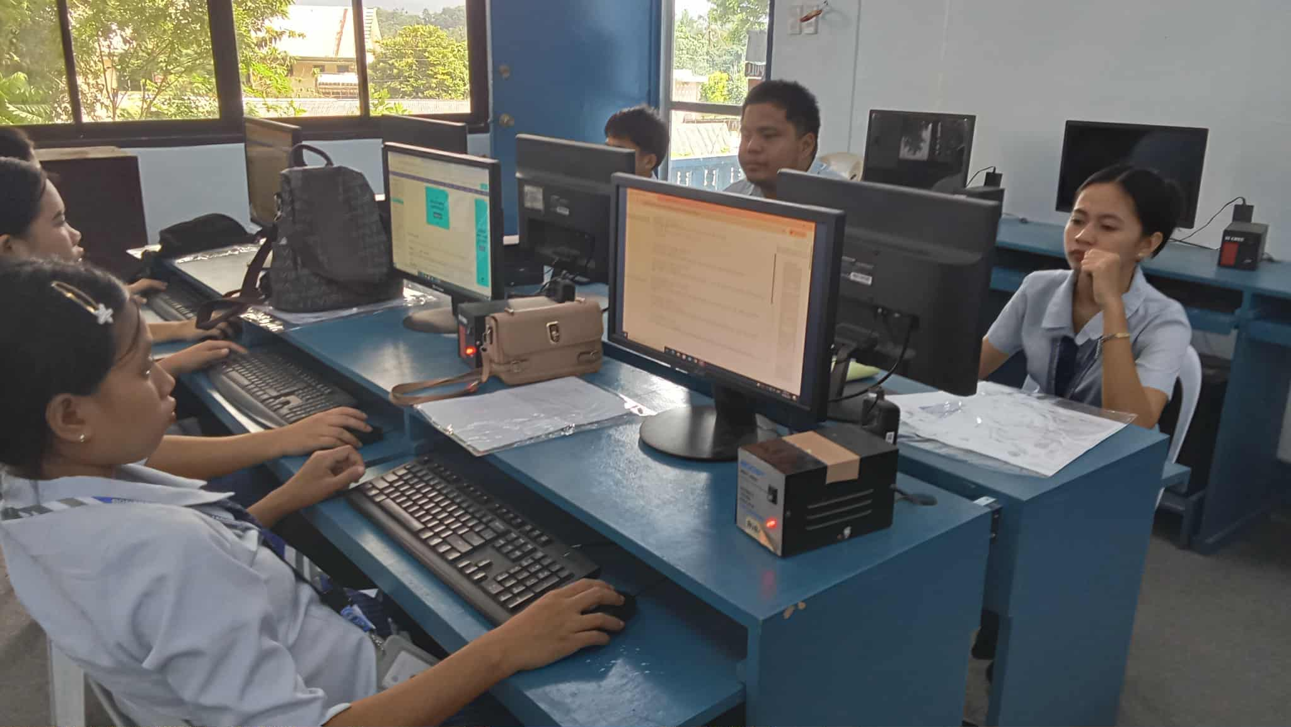
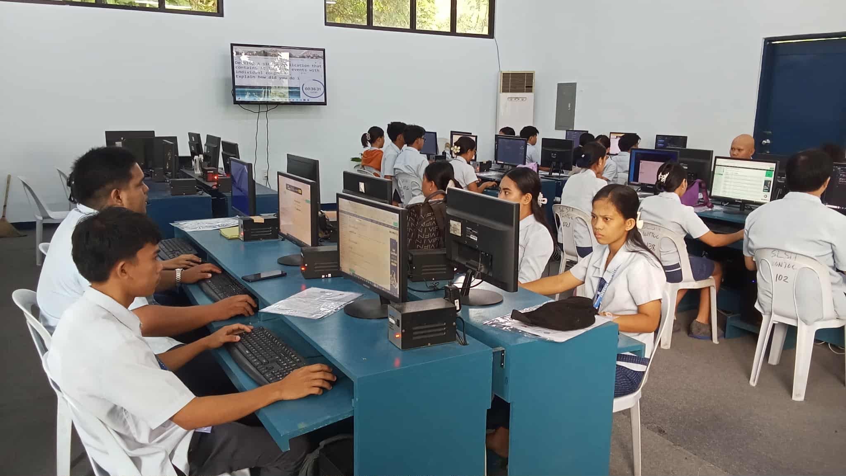

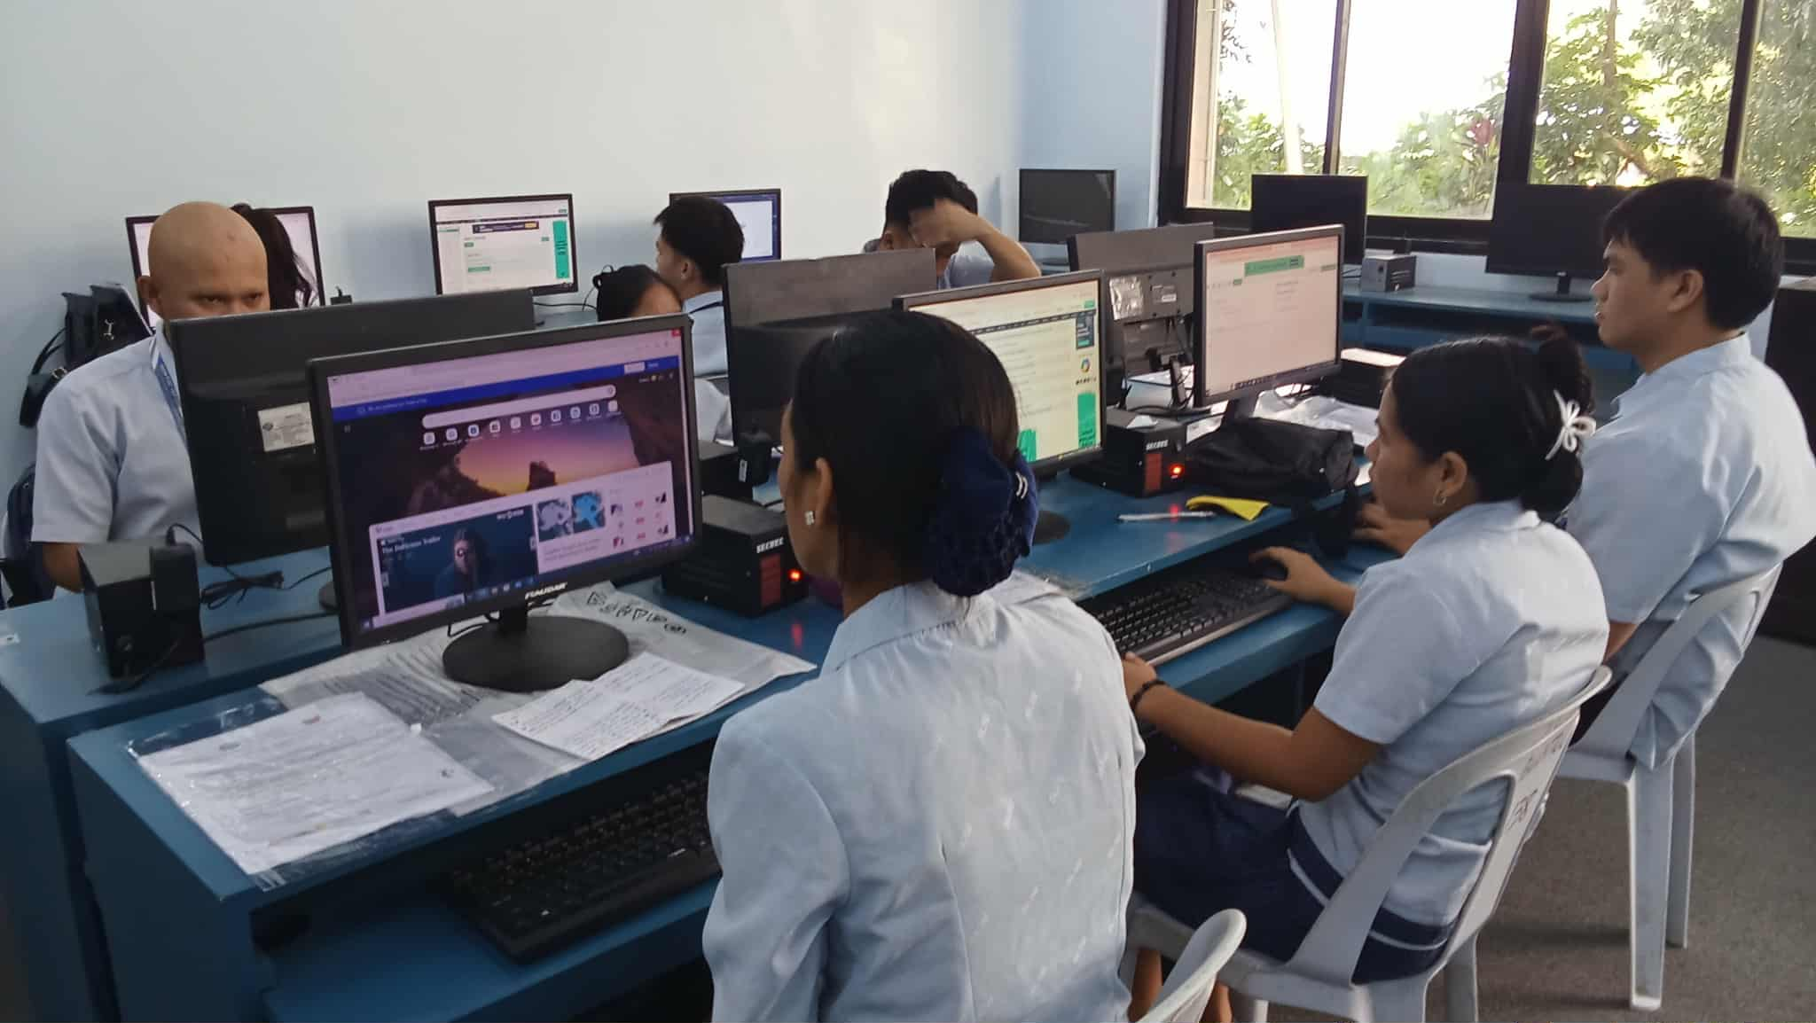

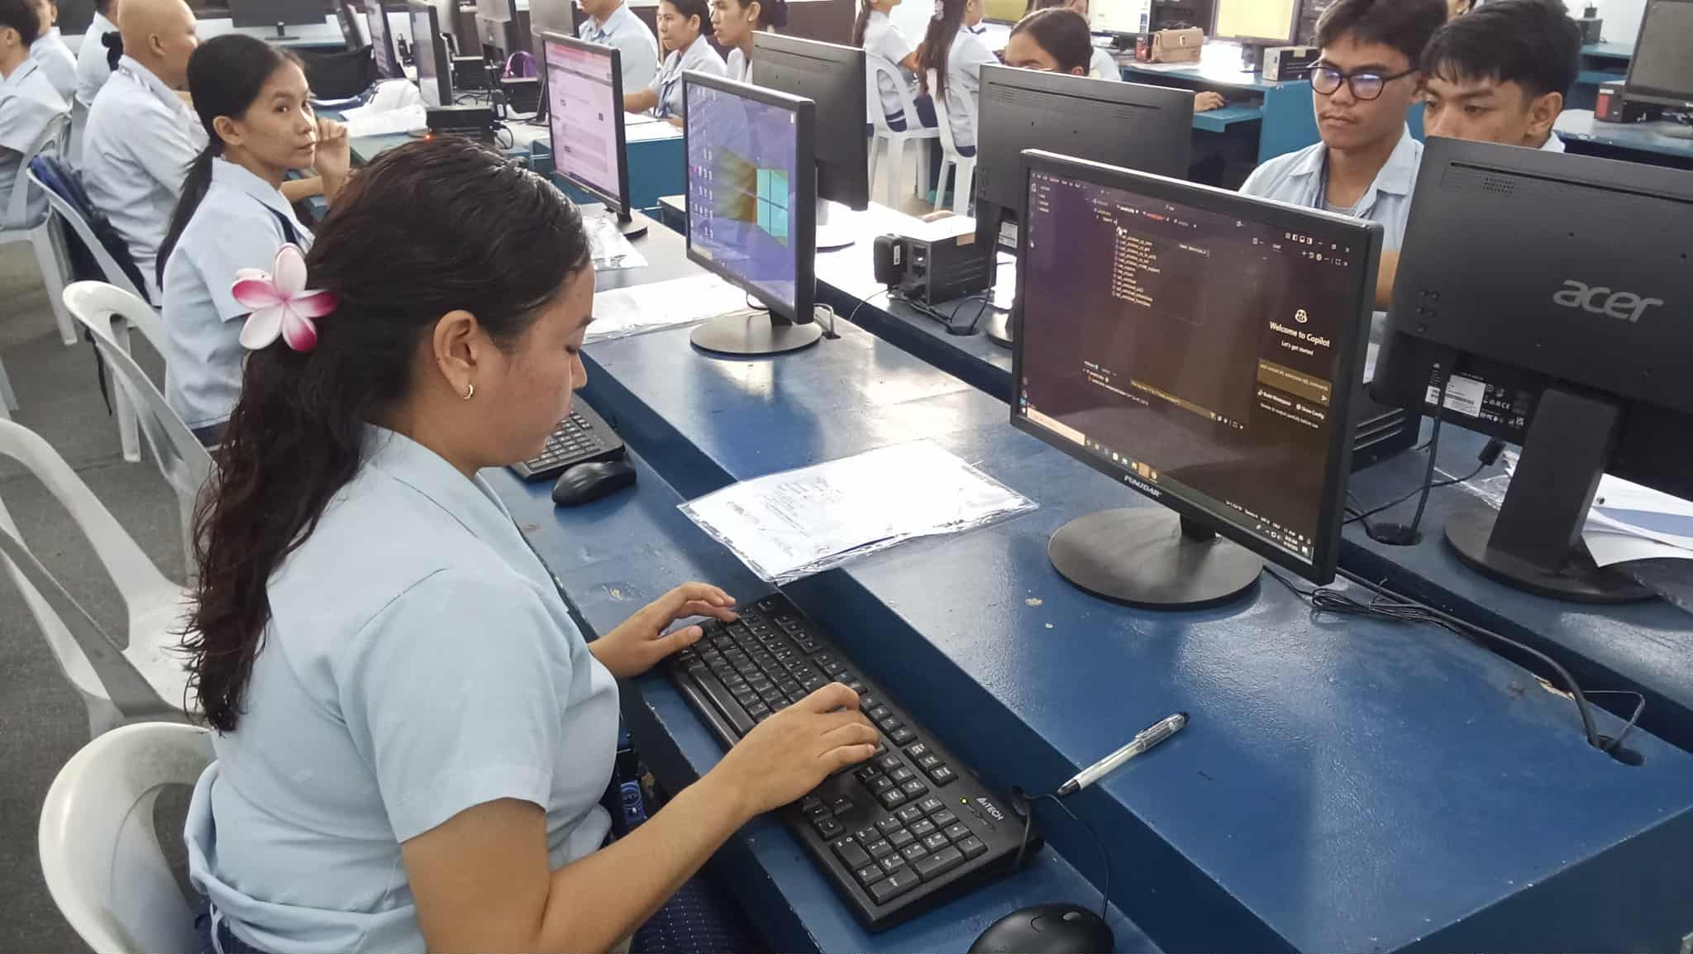
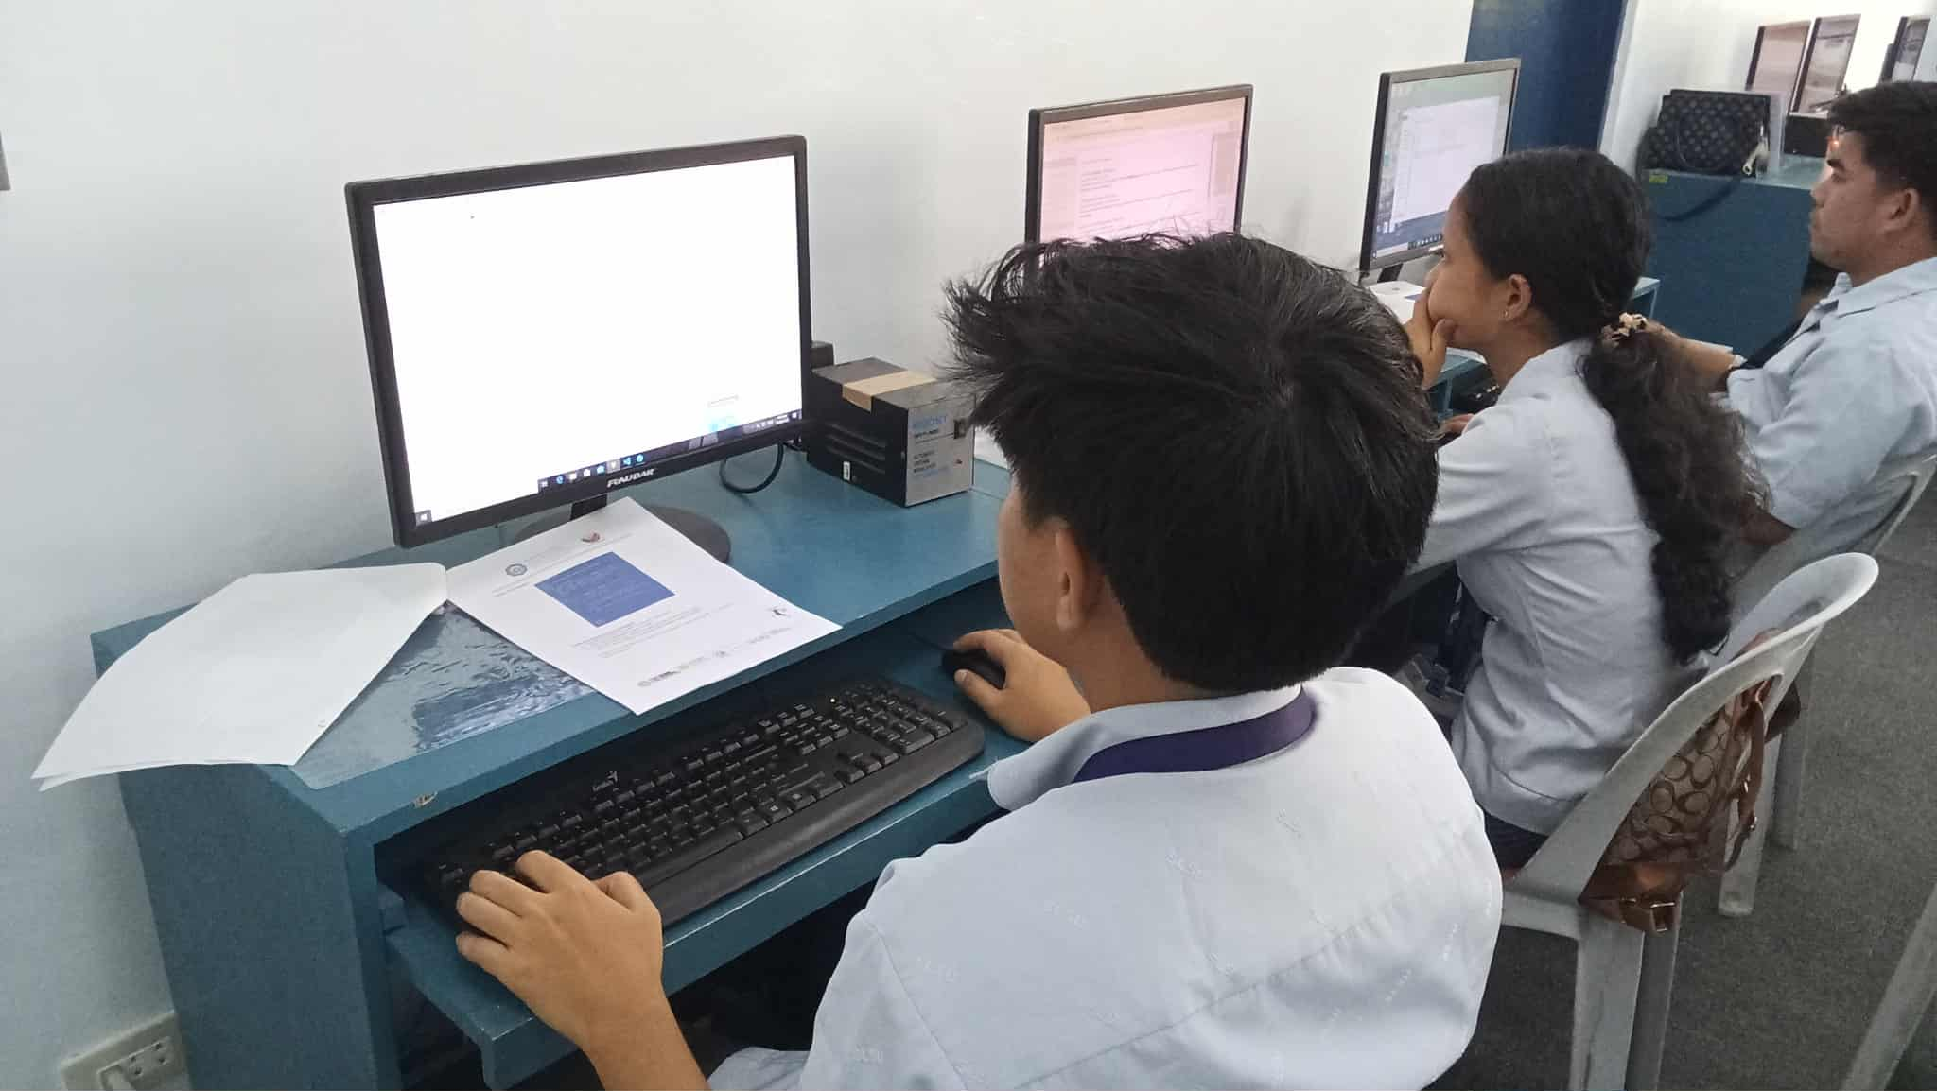

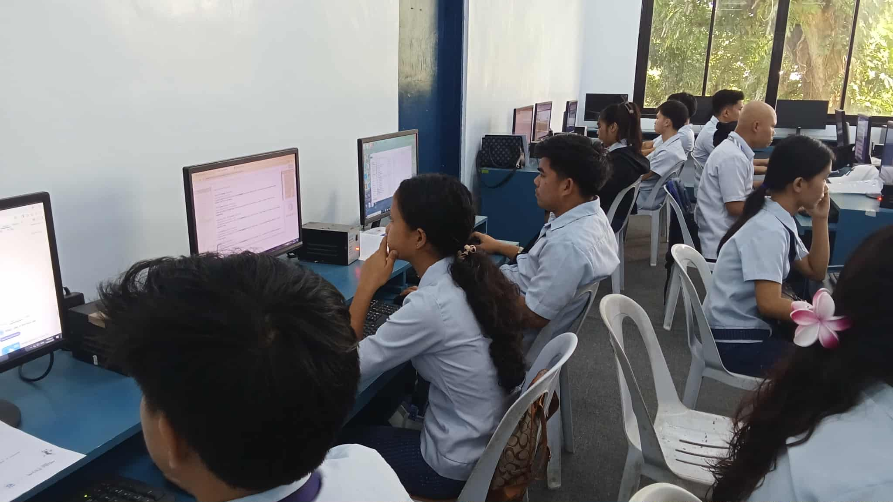

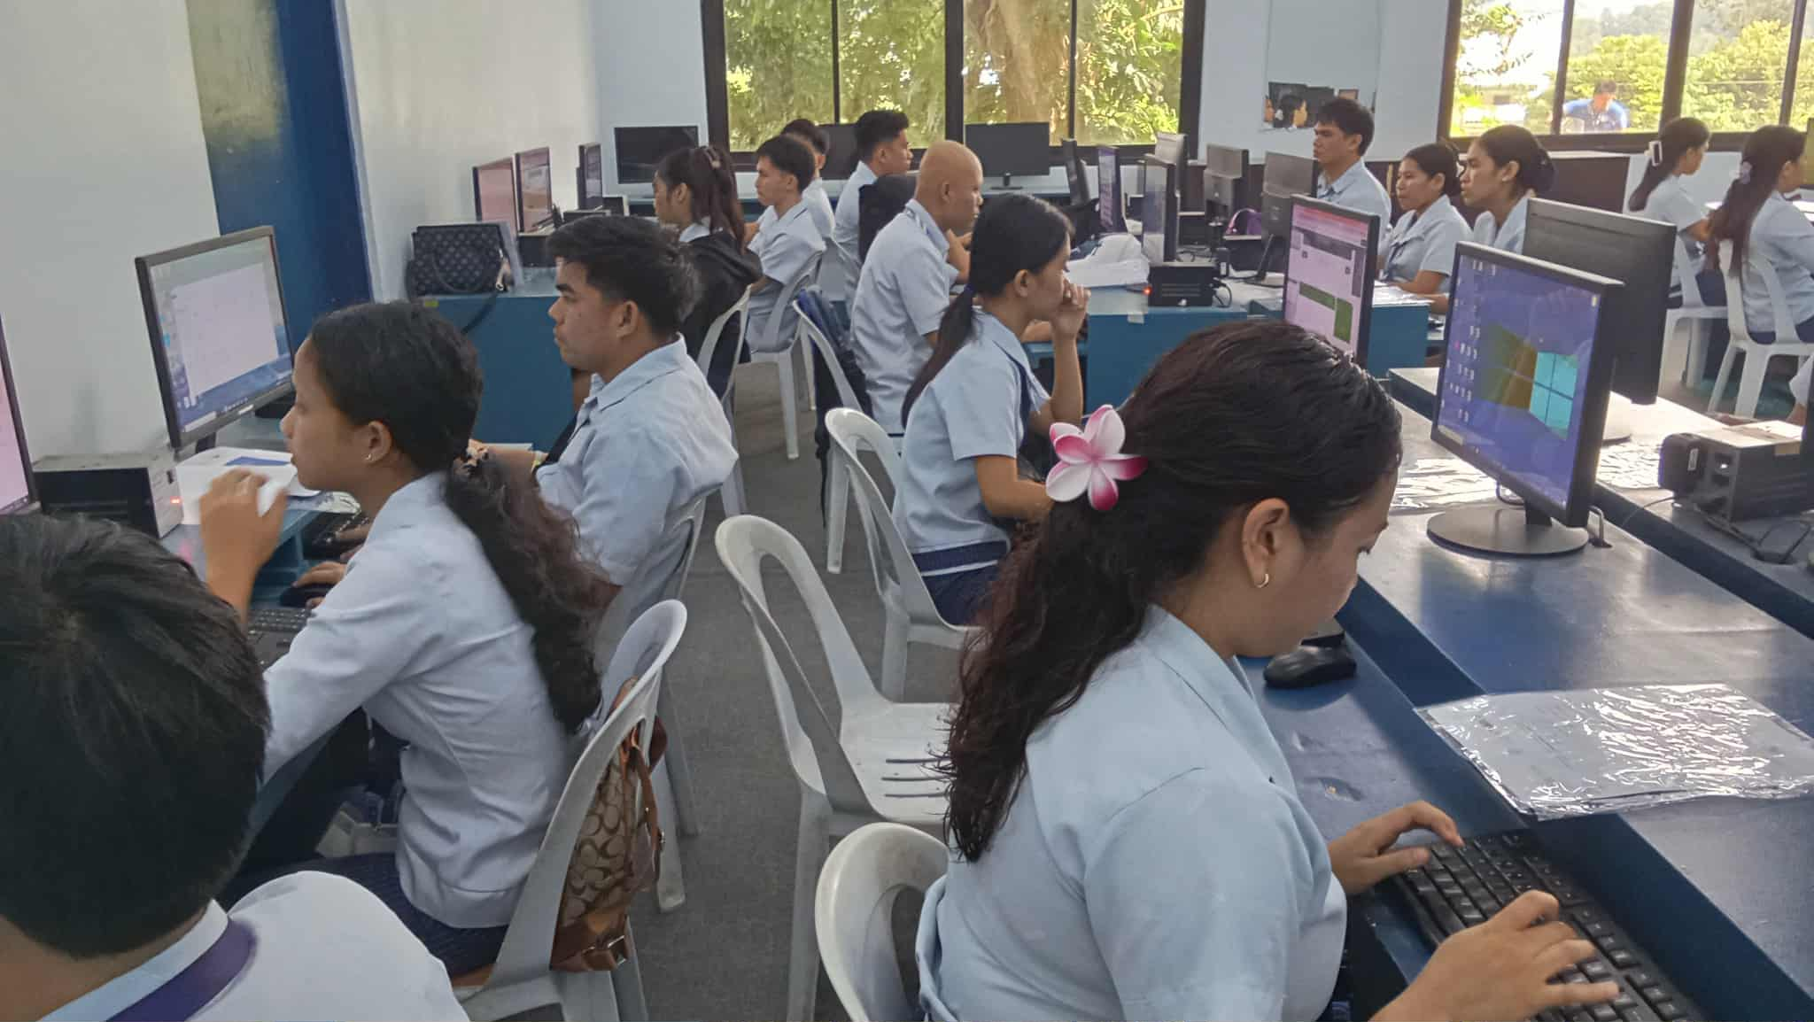
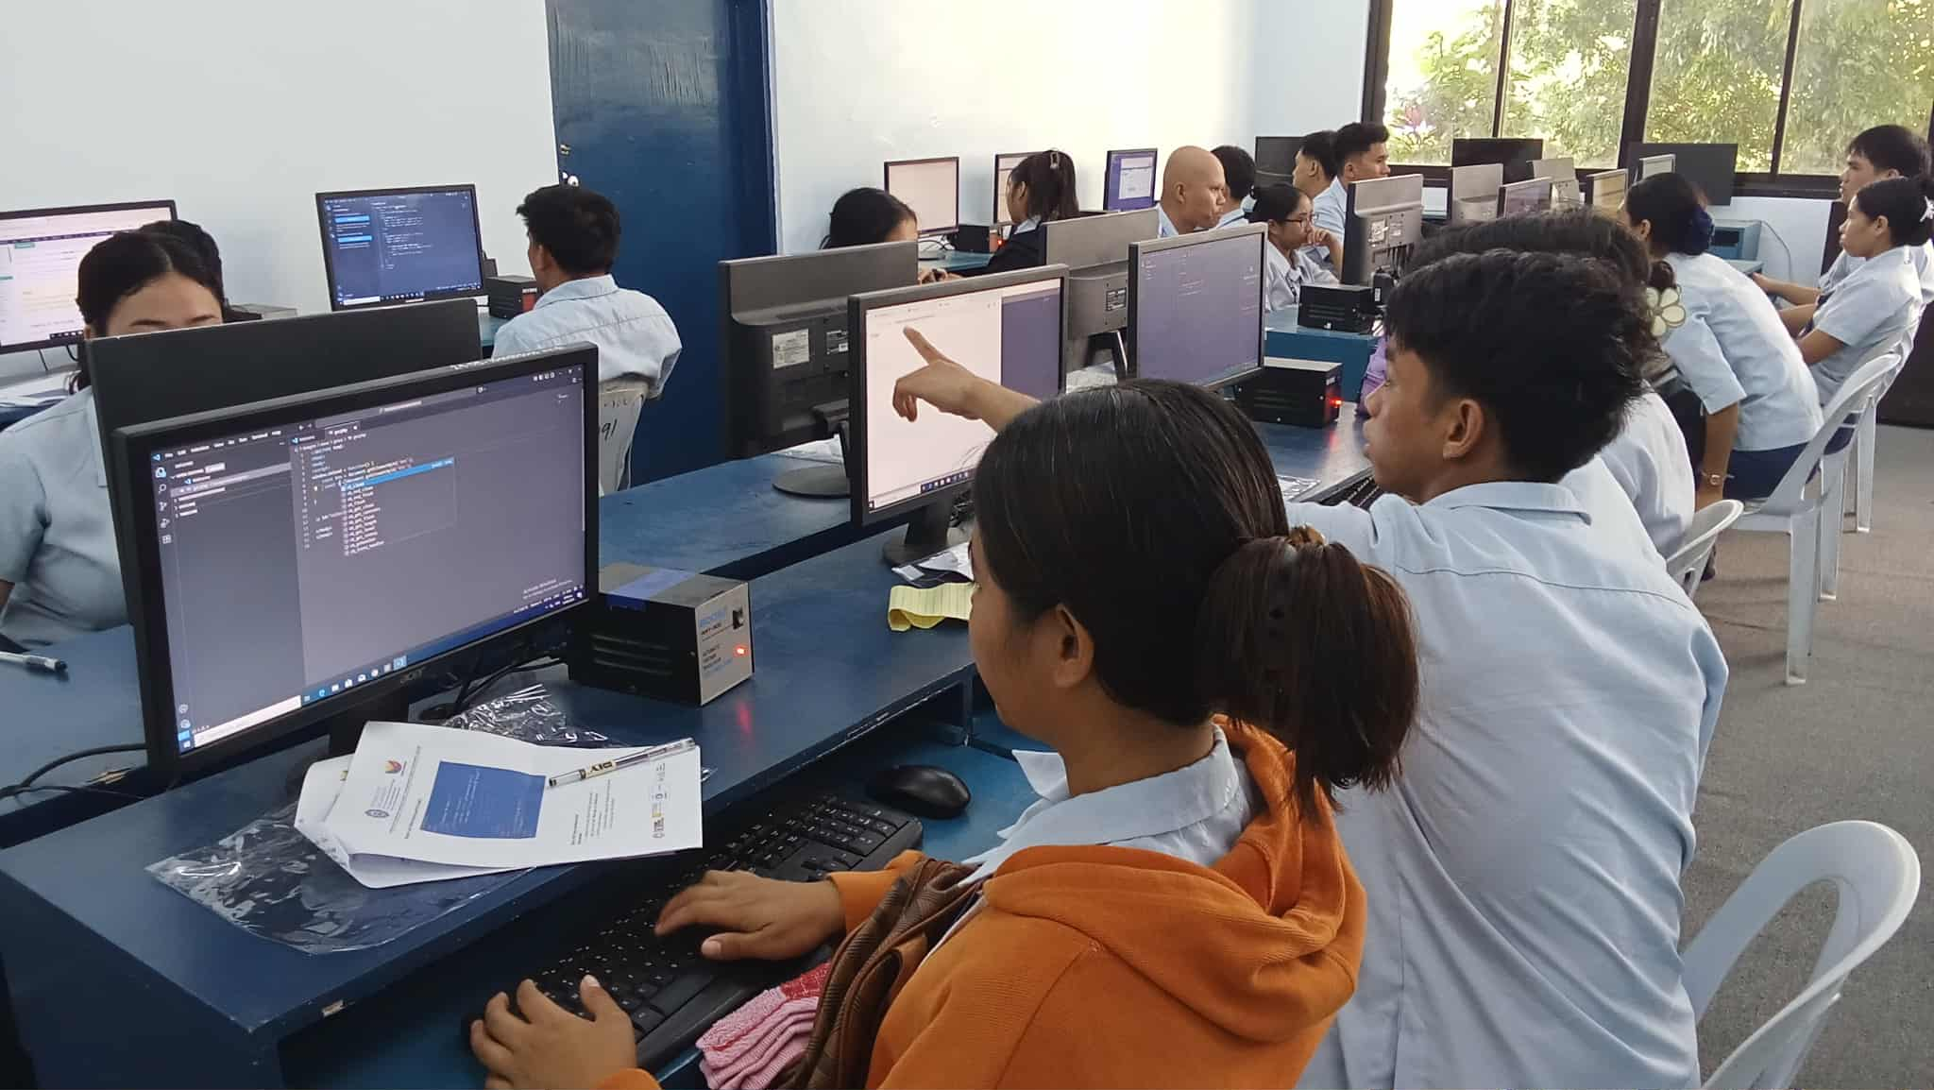

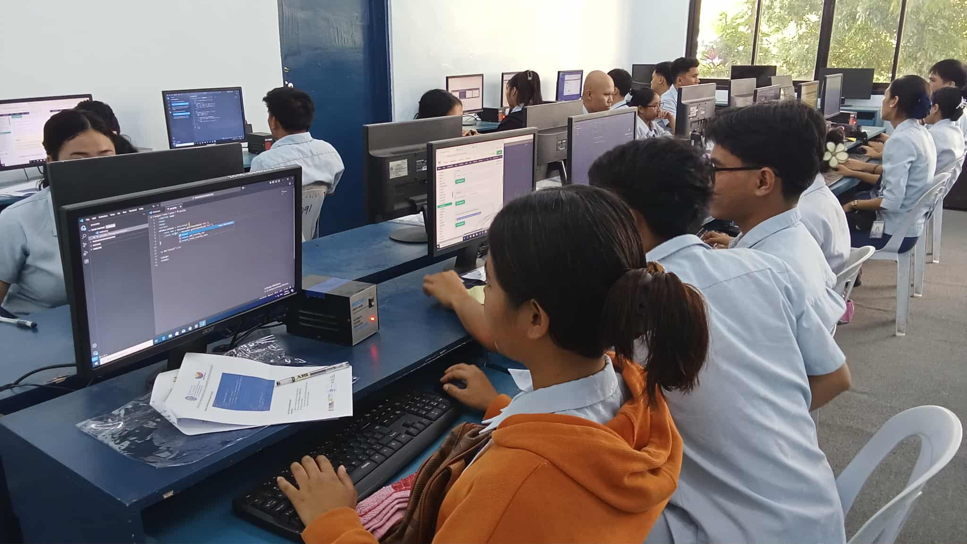

Prepared by: Approved:

JUNNIE RYH M. SUMACOT SHERWIN G. CADAY, PhD.
Instructor Program Chair

